**Task:**

* **First Page:**
* Title for the tab.
* Title for the page
* Image and heading and paragraph for it.
* Image and Link to download it with name “ImageIsDownloaded”.
* Link to send an email.
* Link to open whatsapp conversation with someone.
* Link to navigate to the **second** page.
* Link to navigate to the **third** page.
* **Second page:**
* 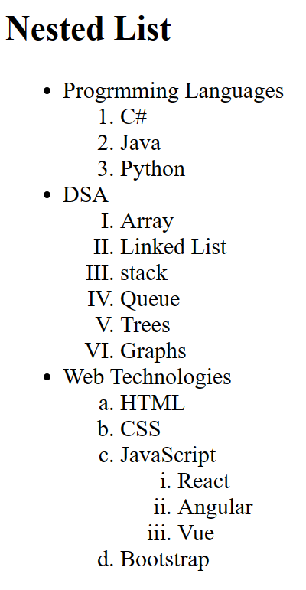Link to go back for the **first** screen.
* **Third page:**
* Link to go back for the **first** page.
* Create a table for grocery shop receipt.
* Each table, th, tr have border.
* Include title with italic font inside the table.
* Include <img> for each fruit using relative path.
* Merge the 3 columns in the last row with total price of all fruits.

**Note: please put it in the head tag:**

    <style>

      table, th, td {

        border: 1px solid black;

      }

    </style>

